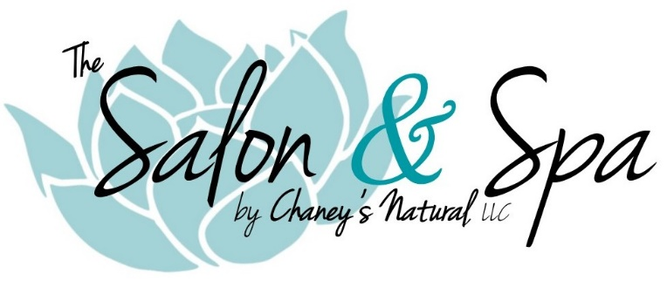
Ionic Detox Foot Bath

Why Detoxify?
Our bodies accumulate different types of toxins every day through eating, drinking and breathing, as well as exposure to medications, chemicals, toxic environments, and heavy metals, (via amalgam fillings, fish consumption, air pollution, etc.) These toxins cause cells within the body to die faster, which can lead to pre-mature aging and diseases. Our bodies have organs and systems to detoxify them, but, over the years, the accumulation of toxins, the effects of illness and disease, improper diet, or a sedentary lifestyle can cause these detoxifying organs to function sub-optimally. This can, in turn, leave us with lethargic and weak immune systems, as well as a susceptibility to several chronic conditions.

How Does Ionic Cleansing Work?
The technology of the Ionic Detoxification system has been in development for the last 150 years. Beginning in 1833, it was discovered that electrical currents could successfully be used to stimulate, transfer, and administrate fluids and specific compounds inside the body.
At that time, it was not understood how fluids were transferred trough cell membranes, but in 2003, the Nobel Prize in Chemistry was awarded to two American scientists, Peter Agre and Roderick MacKinnon, for their discovery of an ion channel system within cell membranes that generates an electrical signal to allow certain nutrients and fluids to pass through the membrane.
This channel system maintains the balance of the bioelectrical distribution of nutrients and waste products in and out of the cell. Almost all the symptoms of aging and degenerative diseases are in one way or another associated with poor hydration within the cell. This diminishes the cell’s ability to repair itself and eliminate toxic waste.
The principle of the Ionic Detoxification system is to use micro current to facilitate the movement or transfer of ions in and out of cells and restore the balance of positive and negative charges of cells. This painless, non-invasive micro current opens the pathways to the vital ion channels.
The “boost” or energy the body receives from the ion water module (array), which sits down in the water during a treatment, allows this amazing detoxification process to occur.
As water is ionized, it is split into H+ and OH- ions, like the way water cascading over a waterfall becomes ionized. These ions are then able to enter the body through the 4,000 large pores of the feet. Then the circulatory and lymphatic systems transport the ions throughout the body.
These ions neutralize oppositely charged toxins in the cells that are normally slow to exit the body. In this way, all the body’s organs, including the liver, intestines, kidneys, lungs, skin and immune system, can become energized and stimulated to function optimally. The body then rids itself of excess toxins through its normal elimination processes and pathways. When the body can eliminate toxins and metabolic waste, then inflammation, edema, and swelling all decrease, allowing the body to repair itself and reduce pain within muscles and joints.

Potential Health Benefits of Ionic Detoxification
- Remove toxins, free radicals, heavy metals, and body waste products that can accumulate, causing several different health issues
- Improve body alkalinity (When the body is more acidic than it should be, it can make the body an ideal breeding ground for worms, parasites, microorganisms and other diseases.)
- Inactivate viruses, bacteria, yeast and fungus
- Relieve pain and tension
- Purify the blood and lymph
- Increase peripheral circulation
- Stimulate and balance the immune system
- Enhance nutrient absorption
- Reduce inflammation and unwanted fluid retention
- Help clear up skin
- Assist in weight loss and improve sleep
- Slow down aging and improve body flexibility
- Quicken recovery from disease or injury
- Increase oxygen in the body
- Rejuvenate and energize your whole body

Recommendations for Effective Detoxification
- To prevent over-activation of digestive organs, do not eat or drink anything during your session.
- After your session, try not to move too rapidly. Take 3-5 minutes or rest and get up slowly.
- Drink plenty of water and try to consume enough fiber, both soluble and insoluble, for the next 2-3 days following your cleanse. These important steps will help to accelerate the elimination of toxins from the body.
- Some good minerals might become depleted during each detox session; therefore, replenishment of these minerals is a must. All detox treatments include a trace mineral replacement drink at the end of therapy.
- It is also possible to drive further toxins into the body, for that reason, we only use pure, filtered water for our treatments.

Additional Treatment Protocol Information
- It is highly recommended that Ionic Detox foot baths not be used if you:
- Have a pacemaker or other electronic implements
- Have had organ removed or received an organ transplant
- Are pregnant or nursing
- Have open wounds on your feet
- Have epilepsy
- Are currently undergoing any forms of radiation or chemotherapy
- Are a hemophiliac or taking blood thinners
- Have had surgery within the last six weeks
- Are 17 years of age or younger

Disclaimer: These statements have not been evaluated by the FDA. The Ionic Detox system is not intended to diagnose, treat, cure or prevent any disease.

